Anatomy and Physiology 2 Final Review

Chapter 17
17.3 Erythrocytes
Erythrocytes play a crucial role in oxygen and carbon dioxide transport
- Describe the structure and function of erythrocytes.
  - Importance of shape, inside components; How the structure helps with oxygen transport
- Three features make for efficient gas transport:
    - Biconcave shape offers huge surface area relative to volume for gas exchange
    - Hemoglobin makes up 97% of cell volume (not counting water)
    - RBCs have no mitochondria
      - ATP production is anaerobic, so they do not consume O₂ they transport
- Describe the structure of hemoglobin.
- Hemoglobin consists of red heme pigment bound to the protein globin
  - Globin is composed of four polypeptide chains
    - Two alpha and two beta chains
  - A heme pigment is bonded to each globin chain
    - Gives blood red color
    - Each heme’s central iron atom binds one O₂

17.4 Leukocytes
Leukocytes defend the body
- List the classes, structural characteristics, and functions of leukocytes.
- Leukocytes grouped into two major categories:
  - Granulocytes: contain visible cytoplasmic granules
      - Agranulocytes: do not contain visible cytoplasmic granules;
- Granulocytes:
  - Three types:Neutrophils, eosinophils, basophils
      - Larger and shorter-lived than RBCs
      - Contain lobed, rather than circular, nuclei
      - Cytoplasmic granules stain specifically with Wright’s stain
      - All are phagocytic to some degree
- Agranulocytes lack visible cytoplasmic granules
- Two types: lymphocytes and monocytes
- Both have spherical or kidney-shaped nuclei

17.7 How do we replace blood in an emergency?
Transfusion can replace lost blood
- Explain what type of blood each blood group can receive; what happens if the an individual gets the wrong blood type.
- Type O universal donor: no A or B antigens
- Type AB universal recipient: no anti-A or anti-B antibodies
- Occur if mismatched blood is infused
        - Donor’s cells are attacked by recipient’s plasma agglutinins
    - Agglutinate and clog small vessels
    - Rupture and release hemoglobin into bloodstream
        - Wrong Blood Type Result in:
    - Diminished oxygen-carrying capacity
    - Decreased blood flow beyond blocked vessel
    - Hemoglobin in kidney tubules can lead to renal failure

Chapter 18
18.1 Anatomy of the heart
The heart has four chambers and pumps blood through the pulmonary and
systemic circuits
- Describe the structure and function of each of the three layers of the heart wall.
  - Epicardium: visceral layer of serous
pericardium
  - Myocardium: circular or spiral bundles of
contractile cardiac muscle cells
    - Cardiac skeleton: crisscrossing, interlacing layer of connective tissue
      - Anchors cardiac muscle fibers
      - Supports great vessels and valves
      - Limits spread of action potentials to specific paths
  - Endocardium: innermost layer; is continuous
with endothelial lining of blood vessels
    - Lines heart chambers and covers cardiac skeleton of valves

18.3 What path does blood take through the heart?
Blood flows from atrium to ventricle, and then to either the lungs or the rest
of the body
- Describe the structure and functions of the four heart chambers. Name each chamber and provide the name and general route of its associated great vessel(s).
- Name the heart valves and describe their location, function, and mechanism of operation.
- Trace the pathway of blood through the heart.
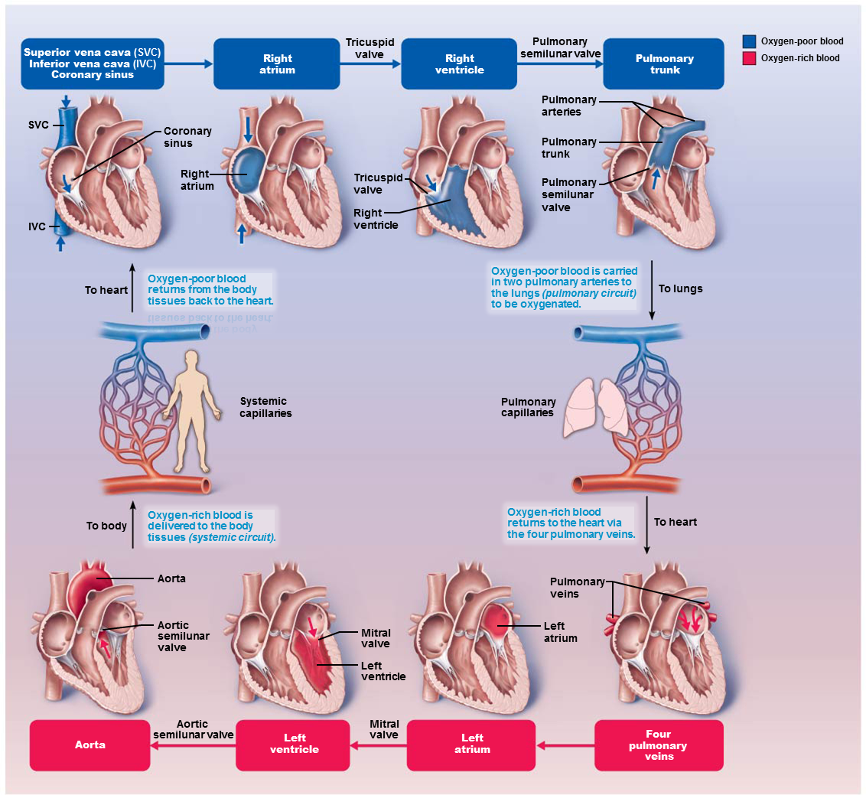

Chapter 20
20.2 Lymphoid cells, tissues, and organs
Lymphoid cells and tissues are found in lymphoid organs and in connective
tissue of other organs
• Describe the basic structure and cellular population of lymphoid tissue. Differentiate
between diffuse and follicular lymphoid tissues.
- Main functions of lymphoid tissue
  - Houses and provides proliferation sites for lymphocytes
  - Offers surveillance vantage points for lymphocytes and macrophages as they filter through lymph
- Largely composed of reticular connective tissue, a type of loose connective tissue
  - Macrophages live on reticular fibers
  - Spaces between fibers offer a place for
lymphocytes to occupy when they return from patrolling body

20.3 Lymph nodes
Lymph nodes filter lymph and house lymphocytes
• Describe the general location, histological structure, and functions of lymph nodes.
- Hundreds of nodes are found throughout body
  - Most are embedded deep in connective tissue in clusters along lymphatic vessels
  - Some are nearer to body surface in inguinal, axillary, and cervical regions of body where collecting vessels converge into trunks
- Cortex
  - Superficial area of cortex contains follicles with germinal centers that are heavy with dividing
B cells
  - Deep cortex houses T cells in transit
    - T cells circulate continuously among blood,
lymph nodes, and lymph
  - Abundant numbers of dendritic cells are closely associated with both T and B cells
    - Play a role in activating both lymphocytes
- Medulla
  - Medullary cords extend inward from cortex and contain B cells, T cells, and plasma cells
- Lymph sinuses are found throughout node
  - Consist of large lymphatic capillaries spanned by crisscrossing reticular fibers
  - Macrophages reside on fibers, checking for and phagocytizing any foreign matter

- Two main functions of lymph nodes
  - Cleansing the lymph: act as lymph “filters”
    - Macrophages remove and destroy microorganisms and debris that enter lymph
      - Prevent unwanted substances from being delivered to blood
  - Immune system activation: offer a place for lymphocytes to become activated and mount an attack against antigens

20.4 Spleen
The spleen removes bloodborne pathogens and aged red blood cells
• Compare and contrast the structure and function of the spleen and lymph nodes.
- Functions
  - Site of lymphocyte proliferation and immune surveillance and response
  - Cleanses blood of aged blood cells and platelets; macrophages remove debris
- Three additional functions of spleen:
  - Stores breakdown products of RBCs (e.g., iron) for later reuse
  - Stores blood platelets and monocytes for release into blood when needed
  - May be site of fetal erythrocyte production
- Histologically, consists of two components
  - White pulp: site where immune function occurs
    - Contains mostly lymphocytes on reticular fibers
    - White pulp clusters are found around central arteries; appear as islands of white in a sea of red pulp
  - Red pulp: site where old blood cells and
bloodborne pathogens are destroyed
    - Rich in RBCs and macrophages that engulf them

20.6 Thymus
T lymphocytes mature in the thymus
• Describe the structure and function of the thymus.
- Thymus: bilobed lymphoid organ found in inferior neck
- Thymus is broken into lobules that contain outer cortex and inner medulla
  - Cortex contains rapidly dividing lymphocytes (the bulk of thymic cells) and scattered macrophages
  - Medulla contains fewer lymphocytes and thymic corpuscles
    - Thymic corpuscles are where regulatory T cells develop
- Thymus differs from other lymphoid organs in important ways
  - Functions strictly in T lymphocyte maturation
  - Provide environment in which T lymphocytes become immunocompetent

Chapter 21
21.2 Innate internal defenses: Cells and chemicals
Innate internal defenses are cells and chemicals that act as the second line of
defense
• Explain the importance of phagocytosis, natural killer cells, and fever in innate body
defense.
- Phagocytes: white blood cells that ingest and digest (eat) foreign invaders
  - Neutrophils: most abundant phagocytes, but die fighting; become phagocytic on exposure to infectious material
  - Macrophages: develop from monocytes and are chief phagocytic cells; most robust phagocytic cell
- Natural Killer Cells
  - Nonphagocytic, large granular lymphocytes that police blood and lymph
  - Can kill cancer and virus-infected cells before adaptive immune system is activated
  - Attack cells that lack “self” cell-surface receptors
- Fever
  - Abnormally high body temperature that is systemic response to invading microorganisms
  - Leukocytes and macrophages exposed to foreign substances secrete pyrogens
  - Pyrogens act on body’s thermostat in hypothalamus, raising body temperature
- Benefits of moderate fever
  - Causes liver and spleen to sequester iron and zinc (needed by microorganisms)
  - Increases metabolic rate, which increases rate
of repair

• Describe the inflammatory process. Identify several inflammatory chemicals and
indicate their specific roles.
- Stages of inflammation
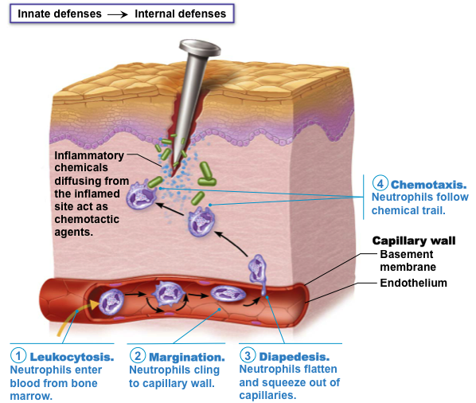

21.4 Lymphocytes and antigen-presenting cells
B and T lymphocytes and antigen-presenting cells are cells of the adaptive
immune response
• Compare and contrast the origin, maturation process, and general function of B and T lymphocytes.
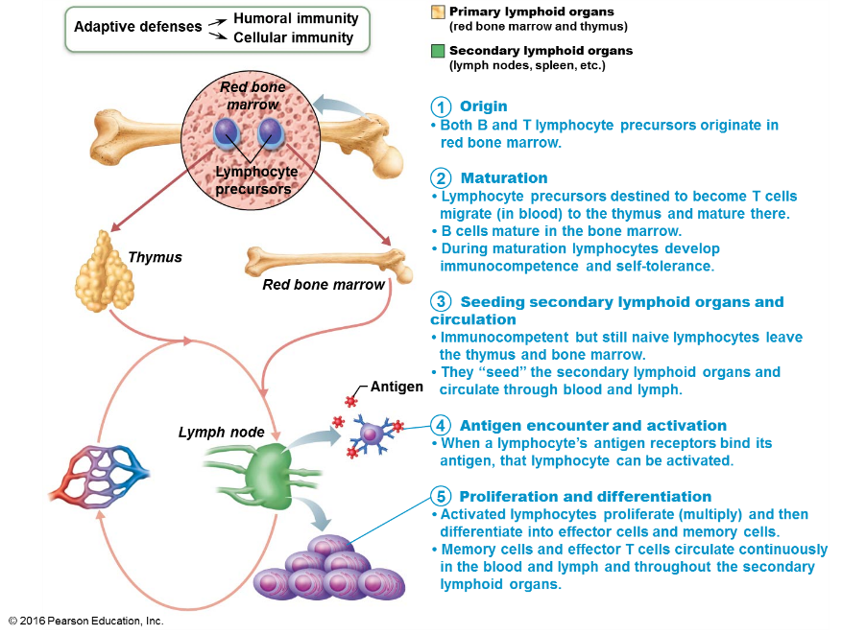

• Name several antigen-presenting cells and describe their roles in adaptive defenses.
- Dendritic cells
  - Found in connective tissues and epidermis
  - Act as mobile sentinels of boundary tissues
  - Phagocytize pathogens that enter tissues, then enter lymphatics to present antigens to T cells in lymph node
- Macrophages
  - Widely distributed in connective tissues and lymphoid organs
  - Present antigens to T cells, which not only activates T cell, but also further activates macrophage

- B lymphocytes
  - Do not activate naive T cells
  - Present antigens to helper T cell to assist their own activation

21.5 Humoral immune response
In humoral immunity, antibodies are produced that target extracellular antigens
• Define humoral immunity.
- When B cell encounters target antigen, it provokes humoral immune response
  - Antibodies specific for that particular antigen are then produced

• Describe the process of clonal selection of a B cell and recount the roles of plasma cells and memory cells in humoral immunity.
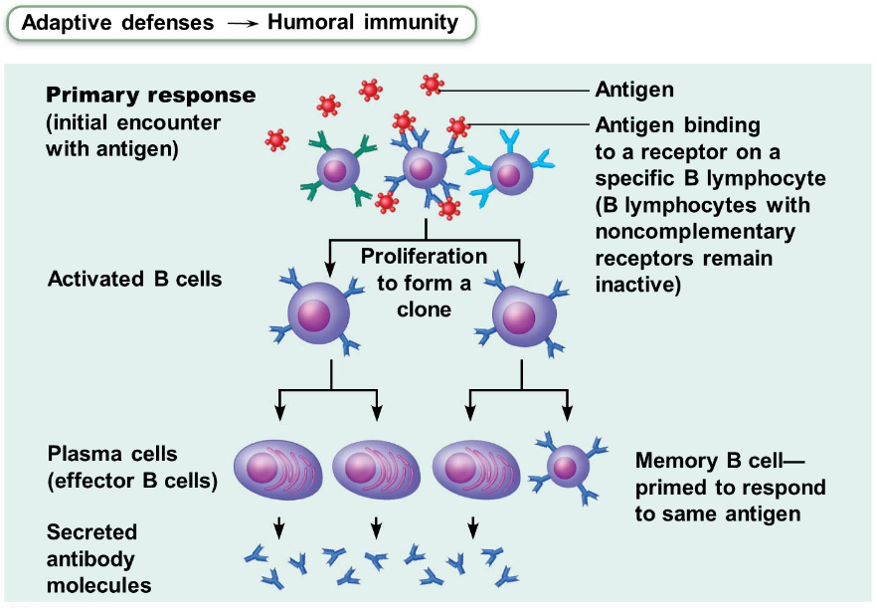

• Compare and contrast active and passive humoral immunity.
- Active humoral immunity occurs when B cells encounter antigens and produce specific antibodies against them
- Two types of active humoral immunity
  - Naturally acquired: formed in response to
actual bacterial or viral infection
  - Artificially acquired: formed in response to
vaccine of dead or attenuated pathogens
- Passive humoral immunity occurs when ready-made antibodies are introduced into body
- Two types of passive humoral immunity
  - Naturally acquired: antibodies delivered to fetus
via placenta or to infant through milk
  - Artificially acquired: injection of serum, such as
gamma globulin

• Describe the structure and functions of antibodies and name the five antibody classes.
- Antibody targets and functions
  - Antibodies do not destroy antigens; they inactivate and tag them
    - Form antigen-antibody (immune) complexes
  - Defensive mechanisms used by antibodies
    - Neutralization
    - Agglutination
    - Precipitation
    - Complement fixation
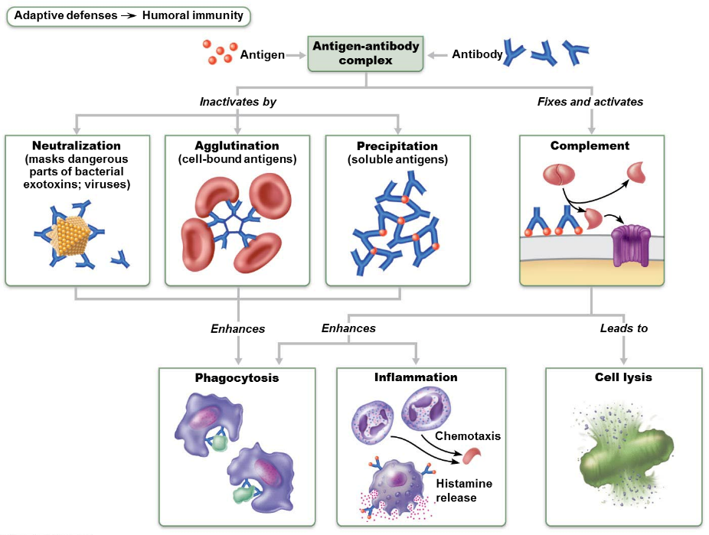

Chapter 22
22.2 The lower respiratory system
The lower respiratory system consists of conducting and respiratory zone
structures
• Distinguish between conducting and respiratory zone structures.
  - Respiratory zone: site of gas exchange
    - Consists of microscopic structures such as respiratory bronchioles, alveolar ducts, and alveoli
  - Conducting zone: conduits that tranport gas to and from gas exchange sites
    - Includes all other respiratory structures
    - Cleanses, warms, and humidifies air
• Describe the structure, function, and location of the larynx, trachea, and bronchi.
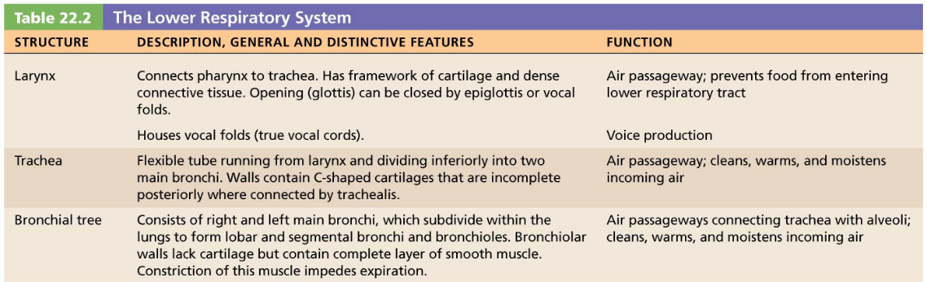

• Identify the organs forming the respiratory passageway(s) in descending order until you reach the alveoli.
- Major organs:
  - Nose and nasal cavity
  - Paranasal sinuses
  - Pharynx
  - Larynx
  - Trachea
  - Bronchi and branches
  - Lungs and alveoli

  - How do we assess ventilation?
Measuring respiratory volumes, capacities, and flow rates helps us assess
ventilation
• Explain and compare the various lung volumes and capacities.
- Tidal volume (TV): amount of air moved into and out of lung with each breath
- Inspiratory reserve volume (IRV): amount of air that can be inspired forcibly beyond the tidal volume
- Expiratory reserve volume (ERV): amount of air that can be forcibly expelled from lungs
- Residual volume (RV): amount of air that always remains in lungs

• Indicate types of information that can be gained from pulmonary function tests.
- Pulmonary functions tests can measure rate of gas movement
  - Forced vital capacity (FVC): amount of gas forcibly expelled after taking deep breath
  - Forced expiratory volume (FEV): amount of gas expelled during specific time interval of FVC
- Obstructive pulmonary disease: increased airway resistance (example: bronchitis)
- Restrictive disease: reduced TLC due to disease (example: tuberculosis) or exposure to environmental agents (example: fibrosis)

Chapter 23
23.1 What major processes occur during digestive system activity?
What major processes occur during digestive system activity?
• List and define the major processes occurring during digestive system activity.
  - Ingestion: eating
  - Propulsion: movement of food through the
alimentary canal, which includes:
    - Swallowing
    - Peristalsis: major means of propulsion of food that involves alternating waves of contraction and relaxation
  - Mechanical breakdown: includes chewing,
mixing food with saliva, churning food in
stomach, and segmentation
    - Segmentation: local constriction of intestine that mixes food with digestive juices
  - Digestion: series of catabolic steps that involves enzymes that break down complex food molecules into chemical building blocks
  - Absorption: passage of digested fragments from lumen of GI tract into blood or lymph
  - Defecation: elimination of indigestible substances via anus in form of feces

23.2 What are the common anatomical features of the digestive system?
The GI tract has four layers and is usually surrounded by peritoneum
• Describe the location and function of the peritoneum.
Peritoneum: serous membranes of abdominal cavity that consists of:
  - Visceral peritoneum: membrane on external surface of most digestive organs
  - Parietal peritoneum: membrane that lines body wall

• Define retroperitoneal and name the retroperitoneal organs of the digestive system.
- Intraperitoneal (peritoneal) organs: organs that are located within the peritoneum
- Retroperitoneal organs: located outside, or posterior to, the peritoneum
  - Includes most of pancreas, duodenum, and parts of large intestine

• Describe the tissue composition and general function of each of the four layers of the alimentary canal.
- Mucosa
    - Functions: different layers perform one or all three
      - Secretes mucus, digestive enzymes, and hormones
      - Absorbs end products of digestion
      - Protects against infectious disease
- Submucosa
    - Contains blood and lymphatic vessels, lymphoid follicles, and submucosal nerve plexus that supply surrounding GI tract tissues
    - Has abundant amount of elastic tissues that help organs to regain shape after storing large meal
- Muscularis externa
    - Muscle layer responsible for segmentation and peristalsis
    - Contains inner circular muscle layer and outer longitudinal layers
      - Circular layer thickens in some areas to form sphincters
- Serosa
    - Outermost layer, which is made up of the visceral peritoneum

Part 2 Functional Anatomy of the Digestive System
23.4 The mouth and associated organs
Ingestion occurs only at the mouth
• Describe the composition and functions of saliva, and explain how salivation is
regulated.
- Composition of saliva
  - Mostly water (97–99.5%), so hypo-osmotic
  - Slightly acidic (pH 6.75 to 7.00)
  - Electrolytes: Na⁺, K⁺, Cl⁻, PO₄²⁻, HCO₃⁻
  - Salivary amylase and lingual lipase
  - Proteins: mucin, lysozyme, and IgA
  - Metabolic wastes: urea and uric acid
  - Lysozyme, IgA, defensins, and nitric oxide from nitrates in food protect against microorganisms

23.6 The stomach
The stomach temporarily stores food and begins protein digestion
• Describe stomach structure and indicate changes in the basic alimentary canal structure that aid its digestive function.
Gross Anatomy of the Stomach
- Stomach is a temporary storage tank that starts chemical breakdown of protein digestion
  - Converts bolus of food to paste-like chime
- Major regions of the stomach
  - Cardial part (cardia): surrounds cardial orifice
  - Fundus: dome-shaped region beneath diaphragm
  - Body: midportion
Pyloric part: wider and more superior portion of pyloric region, antrum, narrows into pyloric canal that terminates in pylorus

• Name the cell types responsible for secreting the various components of gastric juice and indicate the importance of each component in stomach activity.

  - Mucous neck cells
    - Secrete thin, acidic mucus of unknown function
  - Parietal cells
    - Secretions include:
      - Hydrochloric acid (HCl)
        - pH 1.5–3.5; denatures protein, activates pepsin, breaks down plant cell walls, and kills many bacteria
      - Intrinsic factor
        - Glycoprotein required for absorption of vitamin B₁₂ in small intestine
  - Chief cells
    - Secretions include:
      - Pepsinogen: inactive enzyme that is activated to pepsin by HCl and by pepsin itself (a positive feedback mechanism)
      - Lipases
        - Digests ~15% of lipids
  - Enteroendocrine cells
    - Secrete chemical messengers into lamina propria
      - Act as paracrines
        - Serotonin and histamine
      - Hormones
        - Somatostatin (also acts as paracrine) and gastrin

23.7 The liver, gallbladder, and pancreas
The liver secretes bile; the pancreas secretes digestive enzymes
• State the roles of bile and pancreatic juice in digestion.
  - Bile: Yellow-green, alkaline solution containing:
    - Bile salts: cholesterol derivatives that function in fat emulsification and absorption
    - Bilirubin: pigment formed from heme

23.8 The small intestine
The small intestine is the major site for digestion and absorption
• Identify and describe structural modifications of the wall of the small intestine that
enhance the digestive process.
  - Circular folds
    - Permanent folds (~1 cm deep) that force chyme to slowly spiral through lumen, allowing more time for nutrient absorption
  - Villi
    - Fingerlike projections of mucosa (~1 mm high) with a core that contains dense capillary bed and lymphatic capillary called a lacteal for absorption
  - Microvilli
    - Cytoplasmic extensions of mucosal cell that give fuzzy appearance called the brush border that contains membrane-bound enzymes brush border enzymes, used for final carbohydrate and protein digestion

• Differentiate between the roles of the various cell types of the intestinal mucosa.
    - Enterocytes: make up bulk of epithelium
      - Simple columnar absorptive cells bound by tight junctions and contain many microvilli
      - Function
        - Villi: absorb nutrients and electrolytes
        - Crypts: produce intestinal juice, watery mixture of mucus that acts as carrier fluid for chyme
    - Goblet cells: mucus-secreting cells found in
epithelia of villi and crypts
    - Enteroendocrine cells: source of enterogastrones
(examples: CCK and secretin)
      - Found scattered in villi but some in crypts
    - Paneth cells: found deep in crypts, specialized secretory cells that fortify small intestine’s defenses
      - Secrete antimicrobial agents (defensins and lysozyme) that can destroy bacteria
    - Stem cells that continuously divide to produce other cell types
      - Villus epithelium renewed every 2–4 days

Chapter 25
25.2 Nephrons
Nephrons are the functional units of the kidney
• Describe the anatomy of a nephron.
- Two main parts
  - Renal corpuscle
  - Renal tubule

Renal Corpuscle
- Glomerulus
  - Allows for efficient filtrate formation
    - Filtrate: plasma-derived fluid that renal tubules process to form urine
- Glomerular capsule
  - Also called Bowman’s capsule: cup-shaped, hollow structure surrounding glomerulus

Renal tubule is about 3 cm (1.2 in.) long
- Consists of single layer of epithelial cells, but each region has its own unique histology and function
- Three major parts
1. Proximal convoluted tubule
    - Proximal, closest to renal corpuscle
2. Nephron loop
3. Distal convoluted tubule
    - Distal, farthest from renal corpuscle
- Distal convoluted tubule drains into
collecting duct

Chapter 24
24.3 What is metabolism?
Metabolism is the sum of all biochemical reactions in the body
• Define metabolism. Explain how catabolism and anabolism differ.
Anabolism and Catabolism
- Anabolism: synthesis of large molecules from small ones (example: synthesis of proteins from amino acids
- Catabolism: hydrolysis of complex structures to simpler ones (example: breakdown of proteins into amino acids)

• Explain the difference between substrate-level phosphorylation and oxidative
phosphorylation.
  - Substrate-level phosphorylation
    - High-energy phosphate groups are directly transferred from phosphorylated substrates to ADP
  - Oxidative phosphorylation
    - More complex process, but produces most ATP
    - Chemiosmotic process: couples movement of substances across membranes to chemical reactions

24.4 Carbohydrate metabolism
Carbohydrate metabolism is the central player in ATP production
• Summarize important events and products of glycolysis, the citric acid cycle, and
electron transport.
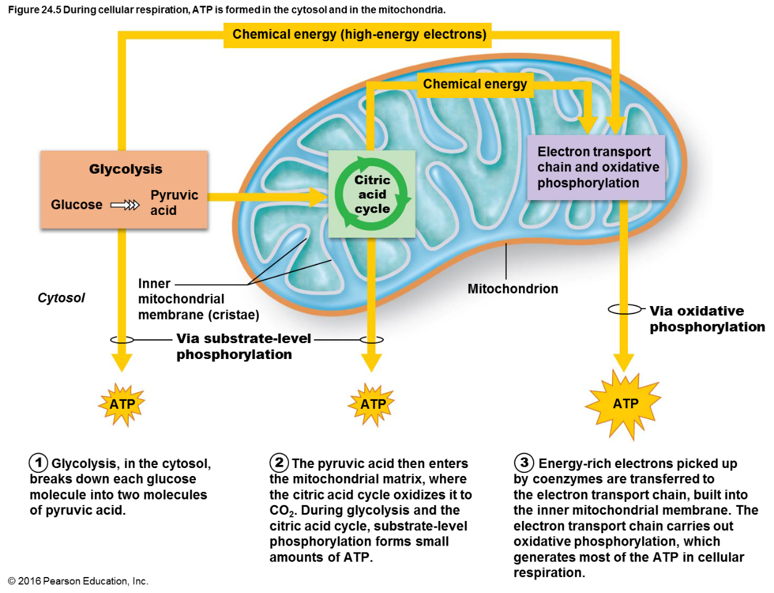

Chapter 26
- Two main fluid compartments
  - Intracellular fluid (ICF) compartment: fluid inside cells accounts for 2/3 of total body fluid
- Extracellular fluid (ECF) compartment: fluid in two main ECF compartments outside cells accounts for one-third of total body fluid

- Three principal abnormalities of water balance
  - Dehydration
    - ECF water loss due to hemorrhage, severe burns, prolonged vomiting or diarrhea, profuse sweating, water deprivation, diuretic abuse, endocrine disturbances
    - Signs and symptoms: “cottony” oral mucosa, thirst,
dry flushed skin, oliguria
    - May lead to weight loss, fever, mental confusion, hypovolemic shock, and loss of electrolytes
  - Hypotonic hydration
    - Cellular overhydration, or water intoxication
    - Occurs with renal insufficiency or rapid excess water ingestion
    - ECF osmolality decreases, causing hyponatremia
      - Results in net osmosis of water into tissue cells and swelling of cells
      - Symptoms: severe metabolic disturbances, nausea, vomiting, muscular cramping, cerebral edema, and possible death
      - Treated with hypertonic saline
  - Edema
    - Atypical accumulation of IF, resulting in tissue swelling (not cell swelling)
      - Only volume of IF is increased, not of other compartments
    - Can impair tissue function by increasing distance for diffusion of oxygen and nutrients from blood into cells
      - Could be caused by increased fluid flow out of blood or decreased return of fluid to blood

