Exam 2 Review
CHAPTER 20
20.1 Lymphatic system
The lymphatic system includes lymphatic vessels, lymph, and lymph nodes
• List the functions of the lymphatic vessels. Describe the structure and distribution of lymphatic vessels.

- Lymphatic vessels offer a one-way system, ensuring lymph flows only toward heart
- Lymph vessels (lymphatics) include:
  - Lymphatic capillaries
  - Larger lymphatic vessels
- Lymphatic capillaries
  - Blind-ended vessels that weave between tissue cells and blood capillaries
    - Absent from bones, teeth, bone marrow, and CNS (CNS uses CSF for drainage)
  - Similar to blood capillaries, but more permeable
  - Can take up larger molecules and particles that blood capillaries cannot
- Larger lymphatic vessels
  - Lymph capillaries drain into increasingly larger vessels called collecting lymphatic vessels
  - Consist of collecting vessels, trunks, and ducts
  - Have structures and tunics similar to veins, except:
    - Have thinner walls, with more internal valves
    - Anastomose more frequently
  - Collecting vessels in skin travel with superficial veins, but deep vessels travel with arteries
- Larger lymphatic vessels (cont.)
  - Lymphatic trunks, which are formed by union of largest collecting vessels, drain large areas of body
- Lymph is delivered from trunks into one of two large lymphatic ducts
  - Right lymphatic duct drains right upper arm and right side of head and thorax
  - Thoracic duct drains rest of body
    - In about half of individuals, starts out as an enlarged sac, cisterna chyli
- Each empties lymph into venous circulation at junction of internal jugular and subclavian veins on its own side of body

• Describe the source of lymph and mechanism(s) of lymph transport.
- Lymph system is a low-pressure system like
venous system
- Lymph is propelled by same mechanisms:
  - Milking action of skeletal muscle
  - Pressure changes in thorax during breathing
  - Valves to prevent backflow
  - Pulsations of nearby arteries
  - Contractions of smooth muscle in walls of lymphatics

20.2 Lymphoid cells, tissues, and organs
Lymphoid cells and tissues are found in lymphoid organs and in connective
tissue of other organs
• Describe the basic structure and cellular population of lymphoid tissue. Differentiate
between diffuse and follicular lymphoid tissues.
- Main functions of lymphoid tissue
  - Houses and provides proliferation sites for lymphocytes
  - Offers surveillance vantage points for lymphocytes and macrophages as they filter through lymph
- Largely composed of reticular connective tissue, a type of loose connective tissue
  - Macrophages live on reticular fibers
  - Spaces between fibers offer a place for
lymphocytes to occupy when they return from patrolling body

  - Diffuse lymphoid tissue: loose arrangement of lymphoid cells and some reticular fibers
  - Lymphoid follicles (nodules): solid, spherical bodies consisting of tightly packed lymphoid cells and reticular fibers

20.3 Lymph nodes
Lymph nodes filter lymph and house lymphocytes
• Describe the general location, histological structure, and functions of lymph nodes.
- Hundreds of nodes are found throughout body
  - Most are embedded deep in connective tissue in clusters along lymphatic vessels
  - Some are nearer to body surface in inguinal, axillary, and cervical regions of body where collecting vessels converge into trunks
- Cortex
  - Superficial area of cortex contains follicles with germinal centers that are heavy with dividing
B cells
  - Deep cortex houses T cells in transit
    - T cells circulate continuously among blood,
lymph nodes, and lymph
  - Abundant numbers of dendritic cells are closely associated with both T and B cells
    - Play a role in activating both lymphocytes
- Medulla
  - Medullary cords extend inward from cortex and contain B cells, T cells, and plasma cells
- Lymph sinuses are found throughout node
  - Consist of large lymphatic capillaries spanned by crisscrossing reticular fibers
  - Macrophages reside on fibers, checking for and phagocytizing any foreign matter

- Two main functions of lymph nodes
  - Cleansing the lymph: act as lymph “filters”
    - Macrophages remove and destroy microorganisms and debris that enter lymph
      - Prevent unwanted substances from being delivered to blood
  - Immune system activation: offer a place for lymphocytes to become activated and mount an attack against antigens

20.4 Spleen
The spleen removes bloodborne pathogens and aged red blood cells
• Compare and contrast the structure and function of the spleen and lymph nodes.
- Functions
  - Site of lymphocyte proliferation and immune surveillance and response
  - Cleanses blood of aged blood cells and platelets; macrophages remove debris
- Three additional functions of spleen:
  - Stores breakdown products of RBCs (e.g., iron) for later reuse
  - Stores blood platelets and monocytes for release into blood when needed
  - May be site of fetal erythrocyte production
- Spleen is encased by fibrous capsule and also has trabeculae
- Histologically, consists of two components
  - White pulp: site where immune function occurs
    - Contains mostly lymphocytes on reticular fibers
    - White pulp clusters are found around central arteries; appear as islands of white in a sea of red pulp
  - Red pulp: site where old blood cells and
bloodborne pathogens are destroyed
    - Rich in RBCs and macrophages that engulf them

20.5 MALT
MALT guards the body’s entryways against pathogens
• Define MALT and list its major components.
- Mucosa-associated lymphoid tissue (MALT)
  - Lymphoid tissues in mucous membranes throughout body
  - Protects from pathogens trying to enter body
  - Found in mucosa of respiratory tract, genitourinary organs, and digestive tract;
largest collections of MALT found in
    - Tonsils
    - Peyer’s patches
    - Appendix

20.6 Thymus
T lymphocytes mature in the thymus
• Describe the structure and function of the thymus.
- Thymus: bilobed lymphoid organ found in inferior neck
- Thymus is broken into lobules that contain outer cortex and inner medulla
  - Cortex contains rapidly dividing lymphocytes (the bulk of thymic cells) and scattered macrophages
  - Medulla contains fewer lymphocytes and thymic corpuscles
    - Thymic corpuscles are where regulatory T cells develop
- Thymus differs from other lymphoid organs in important ways
  - Has no follicles because it lacks B cells
  - Does not directly fight antigens
    - Functions strictly in T lymphocyte maturation
      - Contains blood thymus barrier: keeps immature T lymphocytes isolated from any antigens to prevent premature activation
  - Stroma is made up of epithelial cells, not
reticular fibers
    - Provide environment in which T lymphocytes become immunocompetent
Chapter 21
21.1 Surface barriers: Skin and mucosae
Surface barriers act as the first line of defense to keep invaders out of the body
• Describe surface membrane barriers and their protective functions.
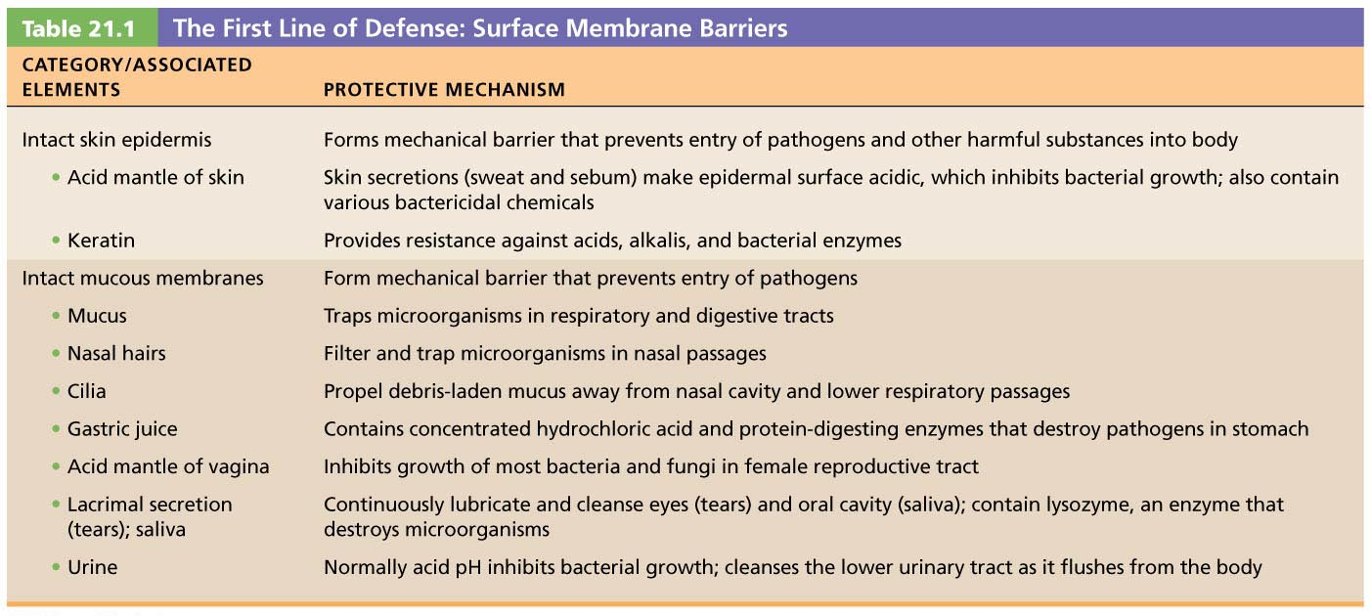
21.2 Innate internal defenses: Cells and chemicals
Innate internal defenses are cells and chemicals that act as the second line of
defense
• Explain the importance of phagocytosis, natural killer cells, and fever in innate body
defense.
- Phagocytes: white blood cells that ingest and digest (eat) foreign invaders
  - Neutrophils: most abundant phagocytes, but die fighting; become phagocytic on exposure to infectious material
  - Macrophages: develop from monocytes and are chief phagocytic cells; most robust phagocytic cell
- Natural Killer Cells
  - Nonphagocytic, large granular lymphocytes that police blood and lymph
  - Can kill cancer and virus-infected cells before adaptive immune system is activated
  - Attack cells that lack “self” cell-surface receptors
  - Kill by inducing apoptosis in cancer cells and virus-infected cells
  - Secrete potent chemicals that enhance inflammatory response
- Fever
  - Abnormally high body temperature that is systemic response to invading microorganisms
  - Leukocytes and macrophages exposed to foreign substances secrete pyrogens
  - Pyrogens act on body’s thermostat in hypothalamus, raising body temperature
- Benefits of moderate fever
  - Causes liver and spleen to sequester iron and zinc (needed by microorganisms)
  - Increases metabolic rate, which increases rate
of repair

• Describe the inflammatory process. Identify several inflammatory chemicals and
indicate their specific roles.
- Stages of inflammation
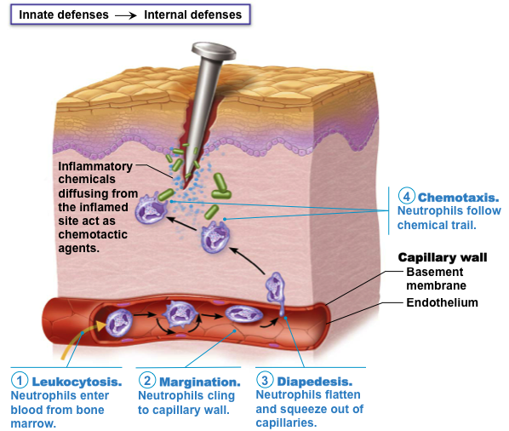
  - Inflammatory chemical release
    - Chemicals are released into ECF by injured tissues, immune cells, or blood proteins
    - Example: histamine released by mast cells is key inflammatory chemical
  - Vasodilation and increased vascular permeability
    - Vasodilation causes hyperemia—congestion with blood—which leads to redness and heat
    - Increased capillary permeability causes
exudate—fluid containing clotting factors and antibodies—to leak into tissue
  - Phagocyte mobilization
    - Neutrophils flood area first; macrophages follow
    - If inflammation is due to pathogens, complement is activated; adaptive immunity elements arrive

• Name the body’s antimicrobial substances and describe their function.
Part 2 Adaptive Defenses
21.3 Antigens
Antigens are substances that trigger the body’s adaptive defenses
• Define antigen and describe how antigens affect the adaptive defenses.
- Antigens: substances that can mobilize adaptive defenses and provoke an immune response

• Define complete antigen, hapten, and antigenic determinant.
- Complete antigens have two important functional properties:
  - Immunogenicity: ability to stimulate proliferation of specific lymphocytes
  - Reactivity: ability to react with activated lymphocytes and antibodies released by immunogenic reactions
- Incomplete antigens, also called haptens, involve molecules too small to be seen so are not immunogenic by themselves
  - Examples: small peptides, nucleotides, some hormones
  - May become immunogenic if hapten attaches to body’s own proteins
  - Causes immune system to mount attack that is harmful to person because it attacks self-proteins as well as hapten
- Antigenic determinants: parts of antigen that antibodies or lymphocyte receptors bind to
  - Most naturally occurring antigens have numerous antigenic determinants that:
    - Mobilize several different lymphocyte populations
    - Form different kinds of antibodies against them

21.4 Lymphocytes and antigen-presenting cells
B and T lymphocytes and antigen-presenting cells are cells of the adaptive
immune response
• Compare and contrast the origin, maturation process, and general function of B and T lymphocytes.
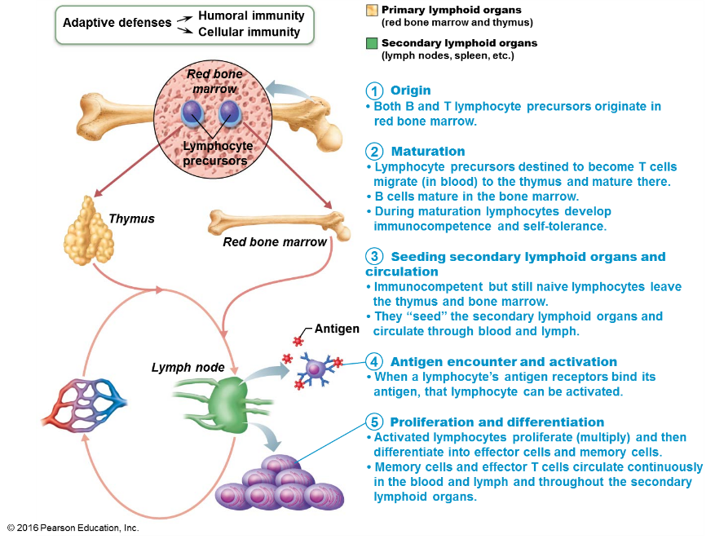

• Name several antigen-presenting cells and describe their roles in adaptive defenses.
- Dendritic cells
  - Found in connective tissues and epidermis
  - Act as mobile sentinels of boundary tissues
  - Phagocytize pathogens that enter tissues, then enter lymphatics to present antigens to T cells in lymph node
- Macrophages
  - Widely distributed in connective tissues and lymphoid organs
  - Present antigens to T cells, which not only activates T cell, but also further activates macrophage
    - Activated macrophage becomes voracious phagocytic killer
- B lymphocytes
  - Do not activate naive T cells
  - Present antigens to helper T cell to assist their own activation

21.5 Humoral immune response
In humoral immunity, antibodies are produced that target extracellular antigens
• Define humoral immunity.
- When B cell encounters target antigen, it provokes humoral immune response
  - Antibodies specific for that particular antigen are then produced

• Describe the process of clonal selection of a B cell and recount the roles of plasma cells and memory cells in humoral immunity.
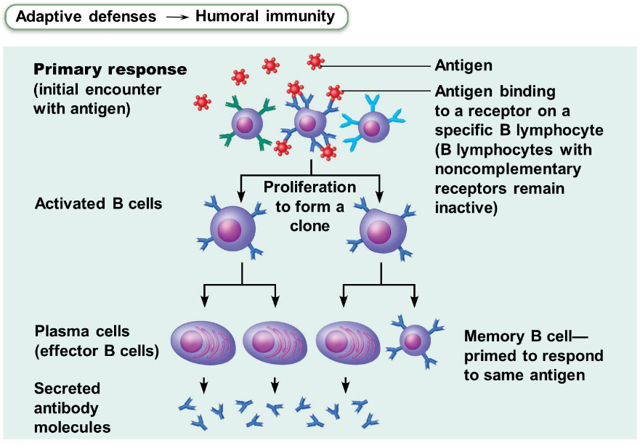

• Compare and contrast active and passive humoral immunity.
- Active humoral immunity occurs when B cells encounter antigens and produce specific antibodies against them
- Two types of active humoral immunity
  - Naturally acquired: formed in response to
actual bacterial or viral infection
  - Artificially acquired: formed in response to
vaccine of dead or attenuated pathogens
- Passive humoral immunity occurs when ready-made antibodies are introduced into body
- Two types of passive humoral immunity
  - Naturally acquired: antibodies delivered to fetus
via placenta or to infant through milk
  - Artificially acquired: injection of serum, such as
gamma globulin

• Describe the structure and functions of antibodies and name the five antibody classes.
- Antibody targets and functions
  - Antibodies do not destroy antigens; they inactivate and tag them
    - Form antigen-antibody (immune) complexes
  - Defensive mechanisms used by antibodies
    - Neutralization
    - Agglutination
    - Precipitation
    - Complement fixation
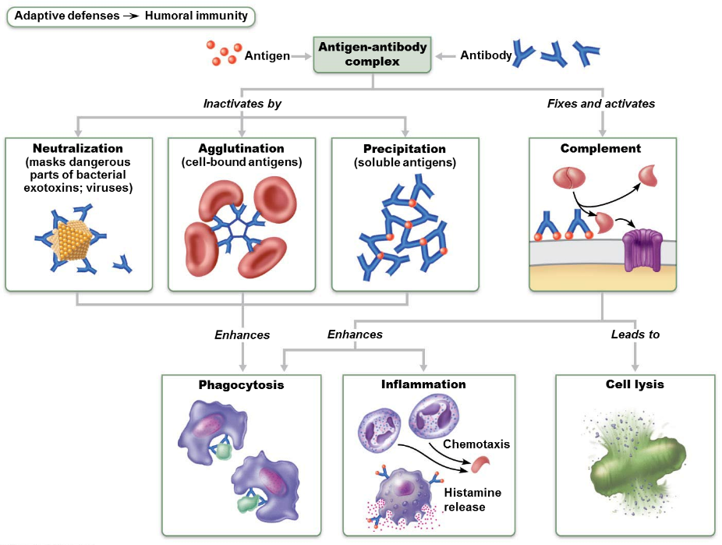
Chapter 22
22.1 The upper respiratory system
The upper respiratory system warms, humidifies, and filters air
• Describe the location, structure, and function of each of the following: nose, paranasal sinuses, and pharynx.
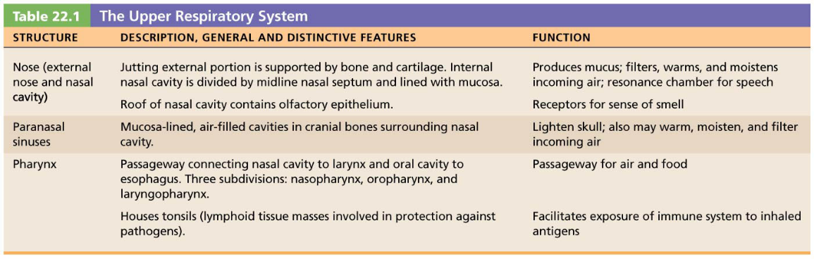
22.2 The lower respiratory system
The lower respiratory system consists of conducting and respiratory zone
structures
• Distinguish between conducting and respiratory zone structures.
  - Respiratory zone: site of gas exchange
    - Consists of microscopic structures such as respiratory bronchioles, alveolar ducts, and alveoli
  - Conducting zone: conduits that tranport gas to and from gas exchange sites
    - Includes all other respiratory structures
    - Cleanses, warms, and humidifies air
• Describe the structure, function, and location of the larynx, trachea, and bronchi.
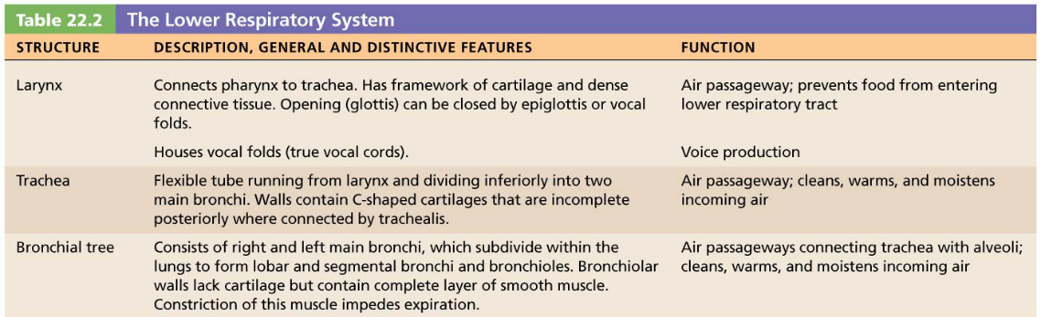

• Identify the organs forming the respiratory passageway(s) in descending order until you reach the alveoli.
- Major organs:
  - Nose and nasal cavity
  - Paranasal sinuses
  - Pharynx
  - Larynx
  - Trachea
  - Bronchi and branches
  - Lungs and alveoli

  - The lungs and pleurae
Each multi-lobed lung occupies its own pleural cavity
• Describe the gross structure of the lungs and pleurae.
Gross Anatomy of the Lungs
- Lungs occupy all of the thoracic cavity except for mediastinum
- Root: site of vascular and bronchial attachment to mediastinum
- Costal surface: anterior, lateral, and posterior surfaces
- Apex: superior tip, deep to clavicle
- Base: inferior surface that rests on diaphragm
- Hilum: found on mediastinal surface, it is the site for entry/exit of blood vessels, bronchi, lymphatic vessels, and nerves
  - What causes air to move in and out of the lungs?
Volume changes cause pressure changes, which cause air to move
• Explain the functional importance of the partial vacuum that exists in the intrapleural space.
  - Pressure in pleural cavity
  - Fluctuates with breathing
  - Always a negative pressure (<P_{atm} and <P_{pul})
  - Fluid level must be kept at a minimum
    - Excess fluid pumped out by lymphatic system
    - If fluid accumulates, positive P_{ip} pressure develops
      - Lung collapses
  - One outward force tends to enlarge lungs
    - Elasticity of chest wall pulls thorax outward
  - Negative P_{ip} is affected by these opposing forces but is maintained by strong adhesive force between parietal and visceral pleurae

• Relate Boyle’s law to events of inspiration and expiration.
Boyle’s law: relationship between pressure and volume of a gas
    - Gases always fill the container they are in
      - If amount of gas is the same and container size is reduced, pressure will increase
    - So pressure (P) varies inversely with volume (V)
    - Mathematically: P₁V₁ = P₂V₂

• Explain the relative roles of the respiratory muscles and lung elasticity in producing the volume changes that cause air to flow into and out of the lungs.
    - Active process involving inspiratory muscles (diaphragm and external intercostals)
      - Action of the diaphragm: when dome-shaped diaphragm contracts, it moves inferiorly and flattens out
        - Results in increase in thoracic volume
      - Action of intercostal muscles: when external intercostals contract, rib cage is lifted up and out
        - Results in increase in thoracic volume

• List several physical factors that influence pulmonary ventilation.
- Airway resistance
  - Friction: major nonelastic source of resistance to gas flow; occurs in airways
- Lung compliance
  - Measure of change in lung volume that occurs with given change in transpulmonary pressure
- Alveolar surface tension
  - Surface tension: the attraction of liquid molecules to one another at a gas-liquid interface

  - How do we assess ventilation?
Measuring respiratory volumes, capacities, and flow rates helps us assess
ventilation
• Explain and compare the various lung volumes and capacities.
- Tidal volume (TV): amount of air moved into and out of lung with each breath
- Inspiratory reserve volume (IRV): amount of air that can be inspired forcibly beyond the tidal volume
- Expiratory reserve volume (ERV): amount of air that can be forcibly expelled from lungs
- Residual volume (RV): amount of air that always remains in lungs

• Define dead space.
- Anatomical dead space: does not contribute to gas exchange
  - Consists of air that remains in passageways
    - ~150 ml out of 500 ml TV
- Alveolar dead space: space occupied by nonfunctional alveoli
  - Can be due to collapse or obstruction
- Total dead space: sum of anatomical and alveolar dead space

• Indicate types of information that can be gained from pulmonary function tests.
- Pulmonary functions tests can measure rate of gas movement
  - Forced vital capacity (FVC): amount of gas forcibly expelled after taking deep breath
  - Forced expiratory volume (FEV): amount of gas expelled during specific time interval of FVC
- Obstructive pulmonary disease: increased airway resistance (example: bronchitis)
- Restrictive disease: reduced TLC due to disease (example: tuberculosis) or exposure to environmental agents (example: fibrosis)

22.6 How do gases move between the lungs, blood, and tissues?
Gases exchange by diffusion among the blood, lungs, and tissues
• Describe how atmospheric and alveolar air differ in composition, and explain these
differences.
Alveoli contain more CO₂ and water vapor than atmospheric air because of:
    - Gas exchanges in lungs (O₂ diffuses out of lung, and CO₂ diffuses into lung)
    - Humidification of air by conducting passages
    - Mixing of alveolar gas with each breath
      - Newly inspired air mixes with air that was left in passageways between breaths

• Relate Dalton’s and Henry’s laws to events of external and internal respiration.
- Dalton’s law of partial pressures
  - Total pressure exerted by mixture of gases is equal to sum of pressures exerted by each gas
- Henry’s law
  - For gas mixtures in contact with liquids:
    - Each gas will dissolve in the liquid in proportion to its partial pressure
    - At equilibrium, partial pressures in the two phases will be equal

