Exam 3 review
Chapter 23
23.1 What major processes occur during digestive system activity?
What major processes occur during digestive system activity?
• List and define the major processes occurring during digestive system activity.
  - Ingestion: eating
  - Propulsion: movement of food through the
alimentary canal, which includes:
    - Swallowing
    - Peristalsis: major means of propulsion of food that involves alternating waves of contraction and relaxation
  - Mechanical breakdown: includes chewing,
mixing food with saliva, churning food in
stomach, and segmentation
    - Segmentation: local constriction of intestine that mixes food with digestive juices
  - Digestion: series of catabolic steps that involves enzymes that break down complex food molecules into chemical building blocks
  - Absorption: passage of digested fragments from lumen of GI tract into blood or lymph
  - Defecation: elimination of indigestible substances via anus in form of feces

23.2 What are the common anatomical features of the digestive system?
The GI tract has four layers and is usually surrounded by peritoneum
• Describe the location and function of the peritoneum.
Peritoneum: serous membranes of abdominal cavity that consists of:
  - Visceral peritoneum: membrane on external surface of most digestive organs
  - Parietal peritoneum: membrane that lines body wall

• Define retroperitoneal and name the retroperitoneal organs of the digestive system.
- Intraperitoneal (peritoneal) organs: organs that are located within the peritoneum
- Retroperitoneal organs: located outside, or posterior to, the peritoneum
  - Includes most of pancreas, duodenum, and parts of large intestine

• Define splanchnic circulation and indicate the importance of the hepatic portal system.
Splanchnic circulation includes:
  - Arteries that branch off aorta to serve digestive organs
    - Hepatic, splenic, and left gastric arteries
    - Inferior and superior mesenteric arteries

• Describe the tissue composition and general function of each of the four layers of the alimentary canal.
- Mucosa
  - Tunic layer that lines lumen
  - Functions: different layers perform one or all three
    - Secretes mucus, digestive enzymes, and hormones
    - Absorbs end products of digestion
    - Protects against infectious disease
- Submucosa
  - Consists of areolar connective tissue
  - Contains blood and lymphatic vessels, lymphoid follicles, and submucosal nerve plexus that supply surrounding GI tract tissues
  - Has abundant amount of elastic tissues that help organs to regain shape after storing large meal
- Muscularis externa
  - Muscle layer responsible for segmentation and peristalsis
  - Contains inner circular muscle layer and outer longitudinal layers
    - Circular layer thickens in some areas to form sphincters
- Serosa
  - Outermost layer, which is made up of the visceral peritoneum
    - Formed from areolar connective tissue covered with mesothelium (single layer of squamous epithelium) in most organs

23.3 How is the digestive system controlled?
The GI tract has its own nervous system called the enteric nervous system
• Describe stimuli and controls of digestive activity.
Three key concepts regulate GI activity
- Digestive activity is provoked by a range of
mechanical and chemical stimuli
  - Receptors located in walls of GI tract organs
  - Respond to stretch, changes in osmolarity and pH, and presence of substrate and end products of digestion
- Effectors of digestive activity are smooth
muscle and glands
  - When stimulated, receptors initiate reflexes that stimulate smooth muscle to mix and move lumen contents
  - Reflexes can also activate or inhibit digestive glands that secrete digestive juices or hormones
- Neurons (intrinsic and extrinsic) and
hormones control digestive activity
  - Nervous system control
    - Intrinsic controls: involve short reflexes (enteric nervous system)
    - Extrinsic controls: involve long reflexes (autonomic nervous system)
  - Hormonal controls
    - Hormones from cells in stomach and small intestine stimulate target cells in same or different organs to secrete or contract

Part 2 Functional Anatomy of the Digestive System
23.4 The mouth and associated organs
Ingestion occurs only at the mouth
• Describe the gross and microscopic anatomy and the basic functions of the mouth and its associated organs.
- Tongue occupies floor of mouth
  - Composed of interlacing bundles of skeletal muscle
  - Functions include:
    - Gripping, repositioning, and mixing of food during chewing
    - Formation of bolus, mixture of food and saliva
    - Initiation of swallowing, speech, and taste
- Palate
  - Palate forms the roof of the mouth and has two distinct parts
    - Hard palate: formed by palatine bones and palatine
processes of maxillae with a midline ridge called
raphe
      - Mucosa is slightly corrugated to help create friction against tongue
    - Soft palate: fold formed mostly of skeletal muscle
      - Closes off nasopharynx during swallowing
- Lips and cheeks
  - Lips (labia): composed of fleshy orbicularis oris muscle
  - Cheeks: composed of buccinator muscles

• Describe the composition and functions of saliva, and explain how salivation is
regulated.
- Composition of saliva
  - Mostly water (97–99.5%), so hypo-osmotic
  - Slightly acidic (pH 6.75 to 7.00)
  - Electrolytes: Na⁺, K⁺, Cl⁻, PO₄²⁻, HCO₃⁻
  - Salivary amylase and lingual lipase
  - Proteins: mucin, lysozyme, and IgA
  - Metabolic wastes: urea and uric acid
  - Lysozyme, IgA, defensins, and nitric oxide from nitrates in food protect against microorganisms

- Minor glands continuously keep mouth moist
- Major salivary glands are activated by parasympathetic nervous system when:
    - Ingested food stimulates chemoreceptors and mechanoreceptors in mouth, sending signals to:
    - Salivatory nuclei in brain stem that stimulate parasympathetic impulses along fibers in cranial nerves VII and IX to glands

23.5 The pharynx and esophagus
The pharynx and esophagus move food from the mouth to the stomach
• Describe the anatomy and basic functions of the pharynx and esophagus.

The Pharynx​

•Food passes from mouth into oropharynx and then into laryngopharynx​
•Allows passage of food, fluids, and air​
•Stratified squamous epithelium lining with mucus-producing glands​
•External muscle layers consists of two skeletal muscle layers​

The Esophagus
  - Flat muscular tube that runs from laryngopharynx to stomach​
  - Is collapsed when not involved in food propulsion​
  - Pierces diaphragm at esophageal hiatus ​
  - Joins stomach at cardial orifice ​
  - Gastroesophageal (cardiac) sphincter surrounds cardial orifice​
  - Keeps orifice closed when food is not being swallowed​
  - Mucus cells on both sides of sphincter help protect esophagus from acid reflux

• Describe the mechanism of swallowing.
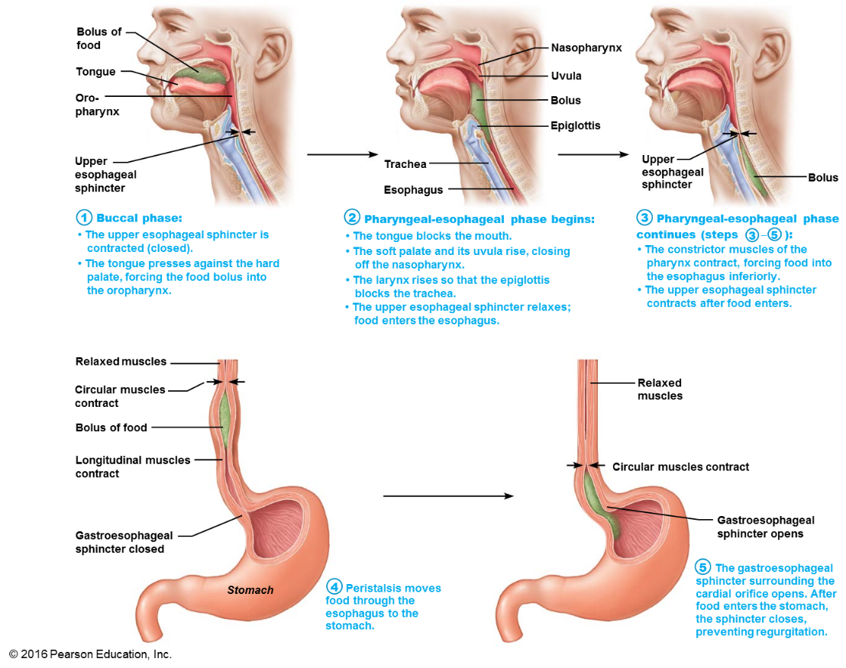

23.6 The stomach
The stomach temporarily stores food and begins protein digestion
• Describe stomach structure and indicate changes in the basic alimentary canal structure that aid its digestive function.
Gross Anatomy of the Stomach
- Stomach is a temporary storage tank that starts chemical breakdown of protein digestion
  - Converts bolus of food to paste-like chime
- Major regions of the stomach
  - Cardial part (cardia): surrounds cardial orifice
  - Fundus: dome-shaped region beneath diaphragm
  - Body: midportion
Pyloric part: wider and more superior portion of pyloric region, antrum, narrows into pyloric canal that terminates in pylorus

• Name the cell types responsible for secreting the various components of gastric juice and indicate the importance of each component in stomach activity.

  - Mucous neck cells
    - Secrete thin, acidic mucus of unknown function
  - Parietal cells
    - Secretions include:
      - Hydrochloric acid (HCl)
        - pH 1.5–3.5; denatures protein, activates pepsin, breaks down plant cell walls, and kills many bacteria
      - Intrinsic factor
        - Glycoprotein required for absorption of vitamin B₁₂ in small intestine
  - Chief cells
    - Secretions include:
      - Pepsinogen: inactive enzyme that is activated to pepsin by HCl and by pepsin itself (a positive feedback mechanism)
      - Lipases
        - Digests ~15% of lipids
  - Enteroendocrine cells
    - Secrete chemical messengers into lamina propria
      - Act as paracrines
        - Serotonin and histamine
      - Hormones
        - Somatostatin (also acts as paracrine) and gastrin

• Explain how gastric secretion and stomach motility are regulated.
- Cephalic (reflex) phase
  - Conditioned reflex triggered by aroma, taste, sight, thought
- Gastric phase
  - Lasts 3–4 hours and provides two-thirds of gastric juice released
  - Stimulation of gastric phase
- Intestinal phase
  - Begins with a brief stimulatory component followed by inhibition
  - Stimulation of intestinal phase
    - Partially digested food enters small intestine, causing a brief release of intestinal (enteric) gastrin
  - Inhibition of intestinal phase
    - Four main factors in duodenum cause inhibition of gastric secretions:
      - Distension of duodenum due to entry of chyme
      - Presence of acidic chyme
      - Presence of fatty chyme
      - Presence of hypertonic chyme

23.7 The liver, gallbladder, and pancreas
The liver secretes bile; the pancreas secretes digestive enzymes
• State the roles of bile and pancreatic juice in digestion.
  - Bile: Yellow-green, alkaline solution containing:
    - Bile salts: cholesterol derivatives that function in fat emulsification and absorption
    - Bilirubin: pigment formed from heme
      - Bacteria break down in intestine to stercobilin that gives brown color of feces

Pancreatic Juices:
    - Watery, alkaline solution (pH 8) to neutralize acidic chyme coming from stomach
    - Electrolytes, primarily HCO₃⁻
    - Digestive enzymes
      - Proteases (for proteins): secreted in inactive form to prevent self-digestion
      - Amylase (for carbohydrates)
      - Lipases (for lipids)
      - Nucleases (for nucleic acids)

• Describe the role of the gallbladder.
- Gallbladder is a thin-walled muscular sac on ventral surface of liver
- Functions to store and concentrate bile by absorbing water and ions

23.8 The small intestine
The small intestine is the major site for digestion and absorption
• Identify and describe structural modifications of the wall of the small intestine that
enhance the digestive process.
  - Circular folds
    - Permanent folds (~1 cm deep) that force chyme to slowly spiral through lumen, allowing more time for nutrient absorption
  - Villi
    - Fingerlike projections of mucosa (~1 mm high) with a core that contains dense capillary bed and lymphatic capillary called a lacteal for absorption
  - Microvilli
    - Cytoplasmic extensions of mucosal cell that give fuzzy appearance called the brush border that contains membrane-bound enzymes brush border enzymes, used for final carbohydrate and protein digestion

• Differentiate between the roles of the various cell types of the intestinal mucosa.
    - Enterocytes: make up bulk of epithelium
      - Simple columnar absorptive cells bound by tight junctions and contain many microvilli
      - Function
        - Villi: absorb nutrients and electrolytes
        - Crypts: produce intestinal juice, watery mixture of mucus that acts as carrier fluid for chyme
    - Goblet cells: mucus-secreting cells found in
epithelia of villi and crypts
    - Enteroendocrine cells: source of enterogastrones
(examples: CCK and secretin)
      - Found scattered in villi but some in crypts
    - Paneth cells: found deep in crypts, specialized secretory cells that fortify small intestine’s defenses
      - Secrete antimicrobial agents (defensins and lysozyme) that can destroy bacteria
    - Stem cells that continuously divide to produce other cell types
      - Villus epithelium renewed every 2–4 days

23.9 The large intestine
The large intestine absorbs water and eliminates feces
• List the major functions of the large intestine.
Part 3 Physiology of Digestion and Absorption
23.10 What are the basic mechanisms of digestion and absorption?
Digestion hydrolyzes food into nutrients that are absorbed across the gut
epithelium
• Describe the general processes of digestion and absorption.
23.11 How is each type of nutrient processed?
How is each type of nutrient processed?
• List the enzymes involved in digestion; name the foodstuffs on which they act.
• List the end products of protein, fat, carbohydrate, and nucleic acid digestion.
• Describe the process by which breakdown products of foodstuffs are absorbed in the small intestine.
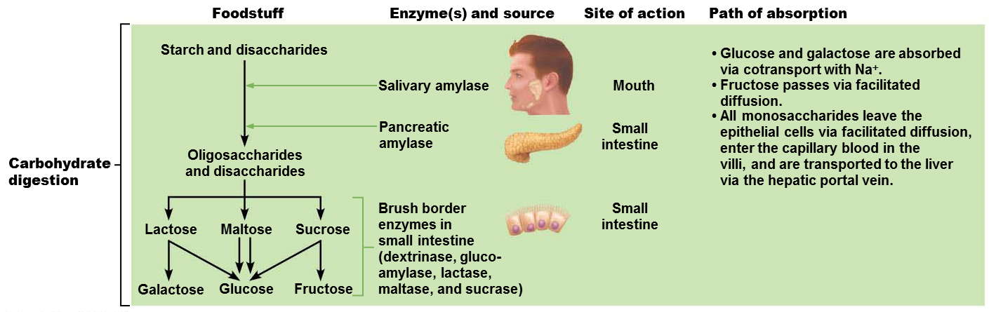
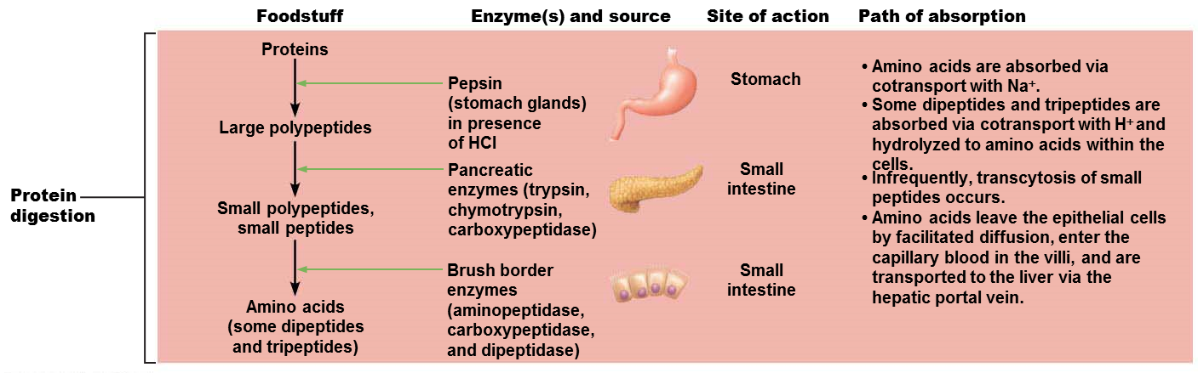
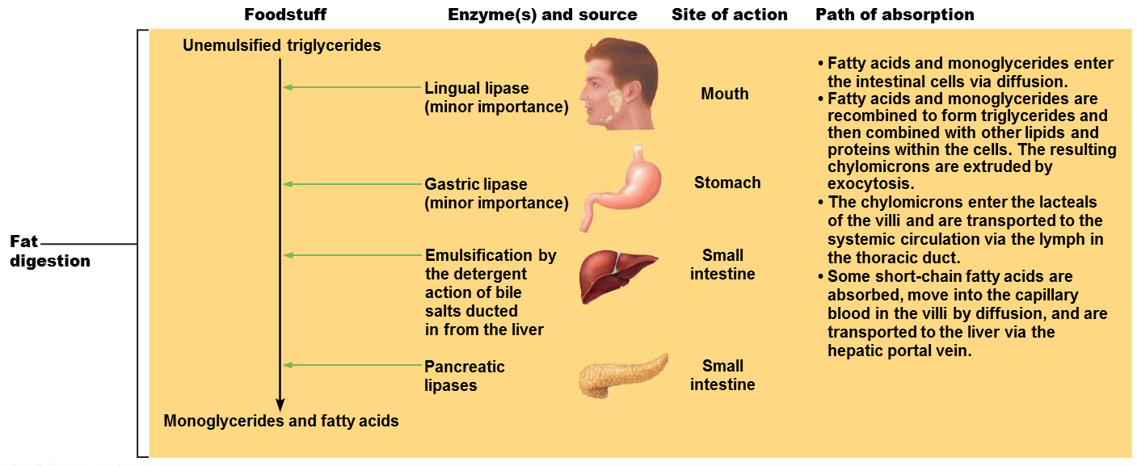

Chapter 25
25.1 Gross anatomy of kidneys
The kidneys have three distinct regions and a rich blood supply
• Describe the gross anatomy of the kidney and its coverings.
  - Renal cortex: granular-appearing superficial
region
  - Renal medulla: deep to cortex, composed of
cone-shaped medullary (renal) pyramids
  - Renal pelvis
    - Funnel-shaped tube continuous with ureter
    - Minor calyces
      - Cup-shaped areas that collect urine draining from pyramidal papillae
    - Major calyces
      - Areas that collect urine from minor calyces
      - Empty urine into renal pelvis

25.2 Nephrons
Nephrons are the functional units of the kidney
• Describe the anatomy of a nephron.
- Two main parts
  - Renal corpuscle
  - Renal tubule
Renal Corpuscle
- Glomerulus
  - Tuft of capillaries composed of fenestrated endothelium
    - Highly porous capillaries
    - Allows for efficient filtrate formation
      - Filtrate: plasma-derived fluid that renal tubules process to form urine
- Glomerular capsule
  - Also called Bowman’s capsule: cup-shaped, hollow structure surrounding glomerulus

Renal tubule is about 3 cm (1.2 in.) long
- Consists of single layer of epithelial cells, but each region has its own unique histology and function
- Three major parts
1. Proximal convoluted tubule
    - Proximal, closest to renal corpuscle
2. Nephron loop
3. Distal convoluted tubule
    - Distal, farthest from renal corpuscle
- Distal convoluted tubule drains into
collecting duct

25.3 How do the kidneys make urine?
Overview: Filtration, absorption, and secretion are the key processes of urine formation
• List and define the three major renal processes.
- Three processes are involved in urine formation and adjustment of blood composition:
1. Glomerular filtration: produces cell- and
protein-free filtrate
2. Tubular reabsorption: selectively returns 99%
of substances from filtrate to blood in renal
tubules and collecting ducts
3. Tubular secretion: selectively moves
substances from blood to filtrate in renal tubules
and collecting ducts

