Why Taxonomy?
Taxonomy – the science of discovering, naming, and understanding organisms on Earth – not only produces fascinating knowledge on the characteristics of life, above all it delivers basic and useable knowledge for many fields of human interest and contributes in many ways to the sustainability of our planet.
It helps us pollinate our trees, manage pests, improve human, animal and plant health, facilitate trade, respond to climate change, conserve our environment, and more. From our earliest time as a species, knowledge on the life surrounding us was essential for our survival. We needed to discover and name plants we could eat, identify poisonous ones, and distinguish the harmful animals from those we benefit from. Today, we still depend on our knowledge on the living world around us.
bione@bionet-intl.org / page 48-51
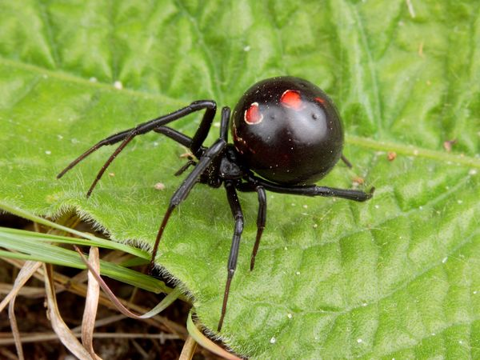
Case Study: Guarding against deadly, eight-legged “black widow” immigrants
Problem Statement: In September 1995, a previously unrecorded spider was found in Osaka, Japan. The spider closely resembled the Red Back Spider from Australia, one of the notorious and highly poisonous “black widow” species. However, Osaka lies several thousand kilometers away from Australia across the Pacific Ocean and has a much colder climate. Were these really Red Back Spiders, surviving a long way north of their usual habitat?
Method: Taxonomic information on spiders is freely available via the World Spider Catalog. Informal networks of spider specialists such as the International Society of Arachnology (ISA) also exist; and all known species of spiders have been cataloged since the 1950’s. In Australia, particular efforts were made to make taxonomic information on spiders readily accessible and a CD-ROM on ‘Spiders of Australia’ was published in 2002. With the help of these resources, spider specialists and identification keys, it was possible to verify that the new spider in Japan was the Australian Red Back or Black Widow
Outcomes and Impacts: The arrival and persistence of the tropical Australian Red Back Spider in Japan is highly significant for other countries with temperate climates, indicating that they are not safe from the introduction of tropical, poisonous spiders and adequate preventive measures need to be taken. As climate change pushes temperate climatic zones further towards the poles, such threats will continue to grow. The Australian Red Back is much more resistant to cold than previously believed. In Japan, they survive temperatures below freezing for periods of several days without ill effects and even reach higher population densities than in Australia.
Lessons: Sound taxonomic knowledge combined with freely accessible taxonomic information on spiders and a worldwide network of experts proved essential for quickly identifying the poisonous spider and developing focused, efficient measures for pest management and public education.
References:
bione@bionet-intl.org
International Society of Arachnology, ISA: http://www.arachnology.org/
World Spider Catalog: http://research.amnh.org/entomology/spiders/catalog81-87/index.html

Questions
- What is taxonomy? How can taxonomy be useful to humans?
- Taxonomy is important for categorizing species.
  - What characteristics of an unidentified spider would be important to categorize it in the same group (genus) as the black widow spider?
  - Predict what would happen to humans if there wasn’t any taxonomy data collected on the black widow spider.
- What is the main difference in environment between Australia and Osaka, Japan? How is natural selection observed in the black widow spider?
- The venom of the black widow spider is a protein that is toxic to nerve cells.
  - What is the basic unit (monomer) of the venom?
  - Predict what would happen if there was a mutation in the gene that produced the venom?
  - The venom works by blocking calcium protein channels that allows calcium to enter nerve cells. This causes a high concentration of calcium on the outside of the cell. The outside of the cell would be considered: hypotonic, isotonic, or hypertonic? Explain why.
  - The venom also contains digestive enzymes. What is the function of the enzyme? What do you think may be a possible substrate of the enzyme?

