Ecological Succession Worksheet
Name __________________________________ Date ________ Period _______
The climax community in the area of Arkansas is an oak-hickory forest. After the ponds are filled in, the area will undergo another series of stages of succession. This is illustrated below. Briefly explain what is happening in the diagram.
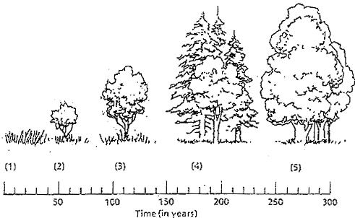
1.
2.
3.
4.
5.
6. List examples of natural events that could lead to secondary succession in this forest?

7. What is the difference between primary and secondary succession?

8. Which organisms will begin the flow of energy in primary succession?

Ecological Succession Worksheet
Name __________________________________ Date ________ Period _______
The climax community in the area of Arkansas is an oak-hickory forest. After the ponds are filled in, the area will undergo another series of stages of succession. This is illustrated below. Briefly explain what is happening in the diagram.
1.
2.
3.
4.
5.
6. List examples of natural events that could lead to secondary succession in this forest?

7. What is the difference between primary and secondary succession?

8. Which organisms will begin the flow of energy in primary succession?

